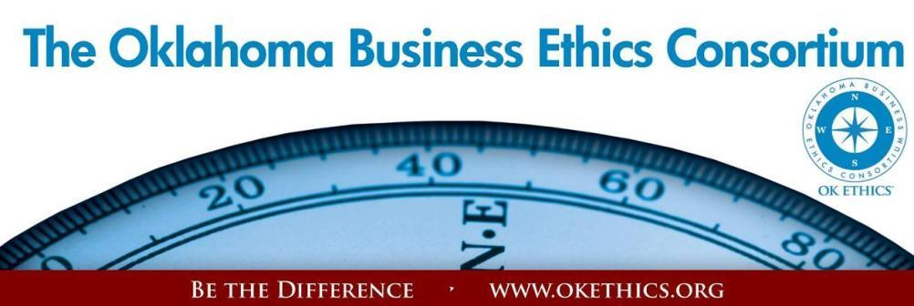
ENTERING OUR TENTH YEAR OF PROMOTING OKLAHOMA VALUES OF INTEGRITY AT WORK!
Agenda – May 15, 2013
- Welcome & Volunteer Appreciation Randy Thurman, Director, OK Ethics Board;
Co-President & CFO of Retirement Investment Advisors

- National Anthem Song led by Carlus Martin, student at Metro Technology Centers

- Acknowledgements Garyl Geist, President, OK Ethics Board of Directors
Chief Operating Officer, Oklahoma Allergy & Asthma Clinic
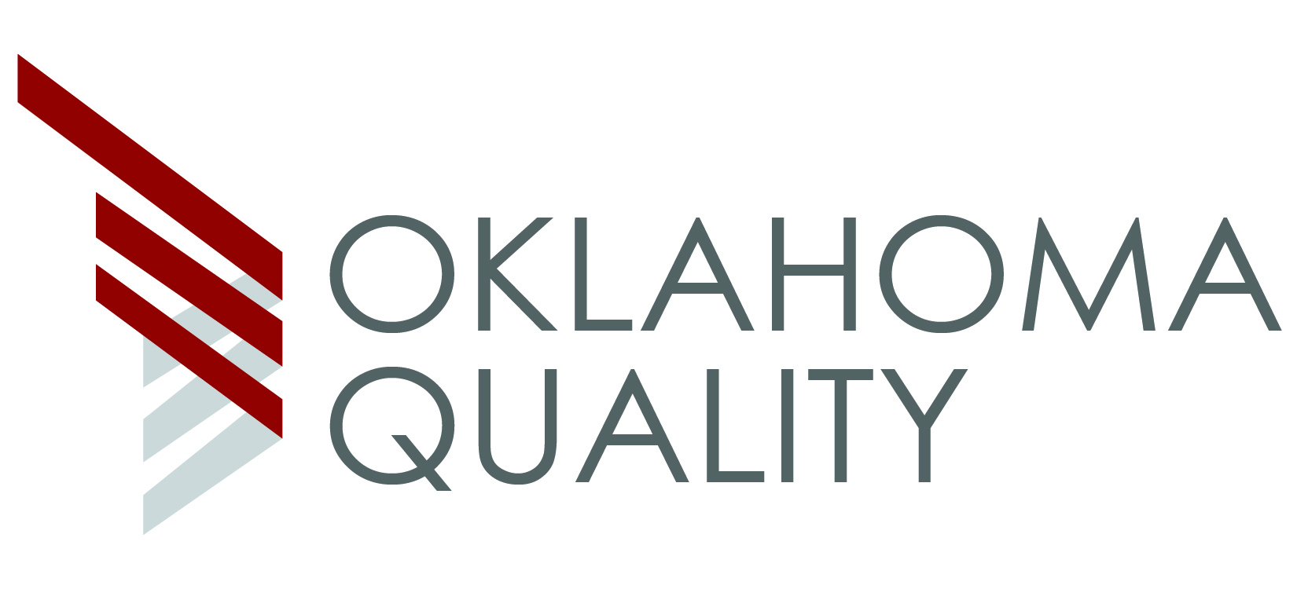
- Oklahoma Quality Foundation & Heather Griswold, Executive Director
- Girl Scouts of Eastern Oklahoma (Non-profits can join for free)
- New Horizon Member: BVA Advanced Eye Care, Inc. – Plaque presentation
- Selection Team Acknowledgement

- Presentation of Executive Pilot Awards Garyl Geist and Myrna Latham, General Counsel,
OK Ethics Board of Directors; Attorney, McAfee Taft
- Thomas Legan, Chairman of Central Oklahoma Region for Prosperity Bank
- Jacque Fiegel, President of Central Oklahoma Region for Prosperity Bank

- Community Impact Award Honorees Shannon Warren, Founder, OK Ethics
and Gregg Koehn, Award Selection Team; President & CEO of Oklahoma Foundation for Medical Quality
Educational Impact:
- Dove Science Academy: Superintendent Umit Alpasian
- Metro Technology Centers: Superintendent Elaine Stith
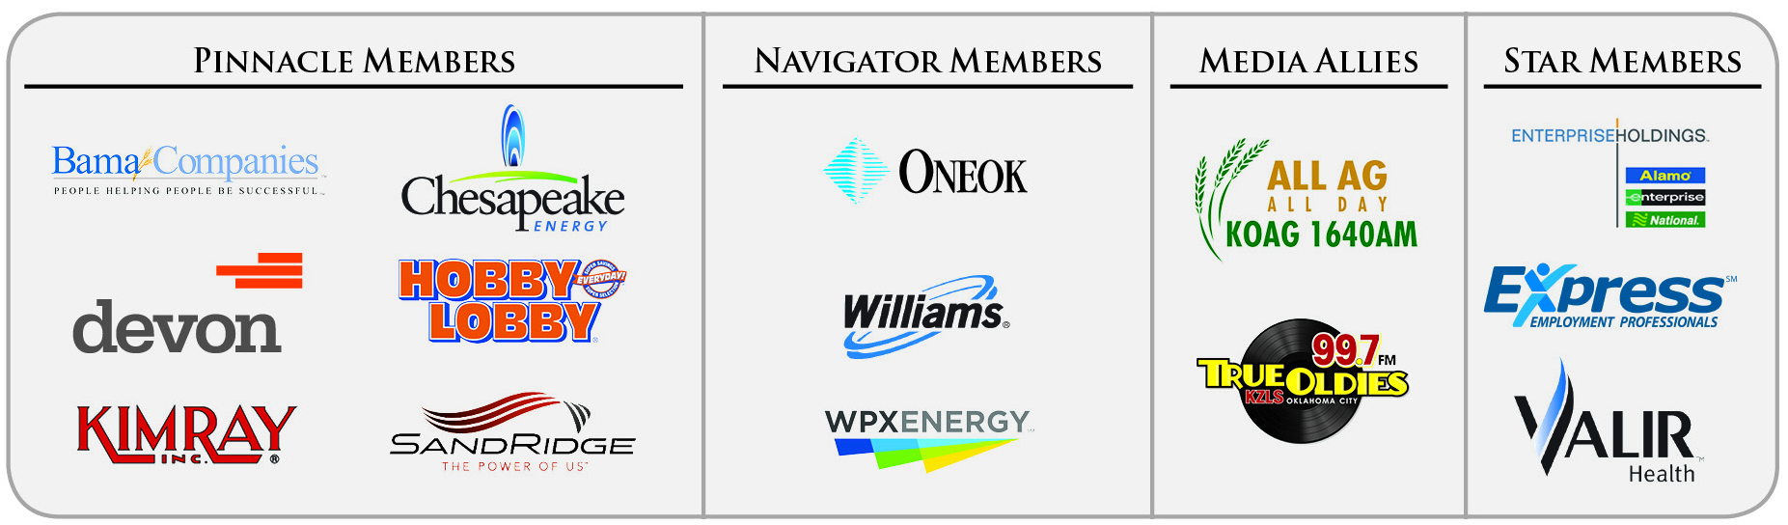
- SandRidge Energy & Public Strategies (Joint Project);
Sandino Thompson, Director of Urban Services for Public Strategies
& Greg Dewey, Senior Vice-President, Communications and Community Relations/SandRidge
Community Impact Award Honorees (Continued) Shannon Warren, Founder, OK Ethics
and Gregg Koehn, Award Selection Team; President & CEO of Oklahoma Foundation for Medical Quality
Overall Community Impact:
- General Tommy Franks Leadership Institute: Warren Martin, Executive Director
- Girl Scouts of Eastern Oklahoma: Roberta Preston, CEO
- The Oklahoma Center for Non-Profits: Marnie Taylor, CEO

- Compass Awards
- Honorable Mention Oscar Jackson, OK Ethics Selection Team
  - CFS2 Bill Bartmann, Founder & CEO
  - Hertz Rob Moore, Senior Vice President, Information Technology Services & Chief Technology Officer
- Award Recipient – Medium Size Company Category Gregg Koehn (See above)
Linde Process Plants, Inc. – Ron Key, Vice President of Technology & Sales

- Award Recipient – Large Size Company Category Carla Brockman, OK Ethics Selection Team; Vice President of Corporate Governance and Secretary for Devon Energy
ONEOK – John Gibson, Chairman and Chief Executive Officer
- Introduction of Keynote Speaker Eric Chester Heather Griswold, Executive Director
Oklahoma Quality Foundation
- Keynote Speaker: Mike Paul, “The Reputation Doctor”
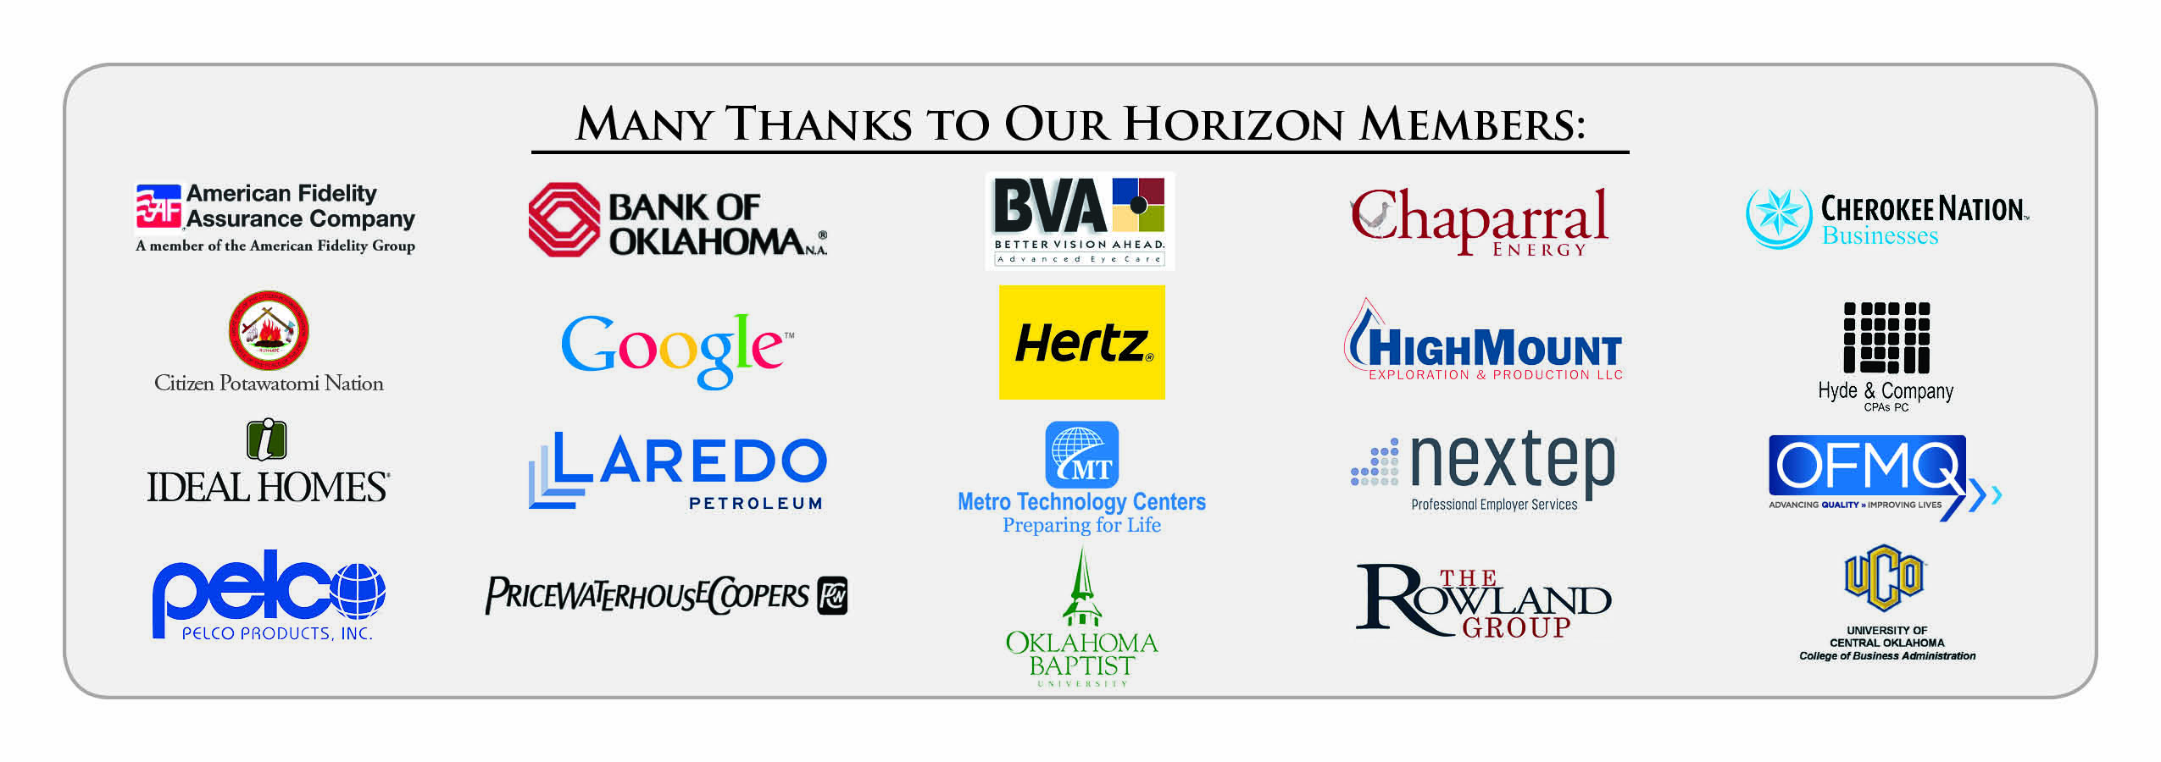
- Adjourn
Questions? Want to volunteer? Visit www.okethics.org ▪ Or call (405) 858-2233 ▪ Email warrenokla@cox.net for Founder, Shannon Warren
Volunteers Needed:
- Membership,
- Ten Year Anniversary Gala,
- and Programs Committees

VOLUNTEER APPRECIATION
OK Ethics relies primarily on volunteers to achieve the organization’s successful pursuit of Oklahoma’s values of integrity at work. It takes leadership and teamwork to host these exciting events and we salute your dedication in achieving OK Ethics’ mission! Listed below are today’s volunteers who consistently provide service to our members:
Agendas: Many thanks to the volunteers from Metro Technology Centers who provide our monthly agendas.

Ambassador Team: These friendly people welcome our guests each month and assist in helping them locate seats. They also arrive early to help distribute agendas and assist with name tags.
John | Burnett | Character First | Ambassadors (Lead – Team 1)
Brent | Martens | Accounting Principals | Ambassadors (Lead – Team 2)
Jamie | Gorman | Hyde & Co. | Ambassadors
Valorie | Hodges | Valir Health | Ambassadors
Bill | Turner | Valir Health | Ambassadors
Daniel | Yunker | Kimray, Inc. | Ambassadors
Nancy | Hyde | Hyde & Co. | Ambassador (Executive Team)
Registration Team: These dependable individuals diligently record our guests’ attendance and handle the collection of fees:
Mark | Neumeister, CPA | D. R. Payne & Associates | Registration Chairperson
Mary | Vaughan CPA | JMA Energy | Guest Registration (Cash & Visitors)
Joe | Walker | Arledge & Associates | Pre-paid Registration Chairperson
Marvinette | Ponder | Devon Energy | Pre-paid Registration – Lead

Special Initiatives:
Michael | Mount | Oklahoma Accountancy Board | CPE's
Susan | Pate | Stinnett & Associates | Accountant
Jalisha | Petties | OK Ethics/Accounting Principals | Member Care Coordinator
Jamie | Potter | Eide Bailly | Facilities Chairperson
Connie | Root | Walker Companies | Recognition Items
Anna | Rosenthal | OK Ethics/Accounting Principals | Name tags
Connie | Rutz | Maximum Multi Media | AV
Shirley | Mears | Champlin Broadcasting | Announcements on  Morning Drive (99.7)

TUNE IN! Our own Bob Byrne and Shirley Mears featured on the morning drive for True Oldies Channel FM 99.7 – Tune in between 7:00 and 8:00 a.m. to learn more about Oklahoma’s legacy! Also, hear interviews with speakers thanks to Champlin Broadcasting and the folks with the Oklahoma Heritage Association who provide the research for our historic profiles!

X. Upcoming Events: OKC Chapter

OKC Summer Break: We will resume our regular monthly programs in August –
Watch emails and Facebook for more details!
OKC BONUS WORKSHOP: Wednesday, June 19; 8:30 to Noon
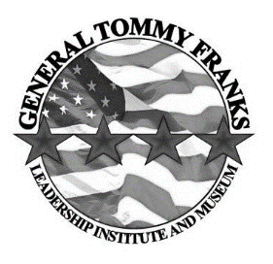
General Tommy Franks Leadership Institute's
INSPIRED LEADERSHIP EXPERIENCE
“A General Tommy Franks Leadership Experience developed in partnership with Cameron University’s School of Business. INSPIRED by the life and LEADERSHIP principles of General Tommy Franks and communicated in an engaging and interactive format that will inspire you to discover your leadership potential.”
What is it?
Honored by OK Ethics with a Community Impact Award, this program is being offered at $75 for non-members and $50 for OK Ethics members. Visit website for more information and to register.
INSPIRED LEADERSHIP is a unique experience that communicates the Four Stars of Leadership exhibited in the life of General Tommy Franks: Character, Communication, Common Vision and Caring. Each session engages participants through illustrations, videos, worksheets, activities, and interactive content which heighten each participant’s ability to learn and retain practical leadership principles. We take into account time parameters, participant demographics, needs of the organization and desired leadership goals to custom mold each experience to the needs of the group through content selection and style of presentation. This enables us to provide leadership training to diverse audiences from middle school students to corporations. Each presentation is generally limited to one of the following formats:

EXPERIENCE
The Inspired Leadership Experience combines historical facts, leadership principles, interactive activities and vivid illustrations that will provide the participant with a comprehensive view of General Franks’ applied leadership style and will assist in the discovery of the participant’s leadership potential. It will also include interactive components that will provide each participant with action steps to apply the leadership principles immediately.
Who is the presenter?
WARREN MARTIN , Executive Director of the General Tommy Franks Leadership Institute and Museum, is the primary presenter of all Inspired Leadership Experiences. Warren has been leading leadership workshops, presenting keynote presentations and consulting with Fortune 500 corporations for 16 years. A Philosophy graduate from Texas Tech and author of 5 books, Warren is known for his unique teaching style. He has worked in 28 countries around the world (mostly in the Middle East and Latin America). He has also worked with teachers, organizations, and youth ministers to develop curriculum and need specific training. Warren has been listed among the top 400 speakers in America. His passion is to invest in the lives of others through servant leadership to assist them in reaching their full potential.
Recommended for 3 CPEs in Ethics
Program is designed at the basic level and is suitable for anyone aspiring to or currently holding a leadership position. Note that it is up to the individual attendees to demonstrate relevance to his/her own area of practice. OK Ethics makes no guarantees.
Upcoming Events: Tulsa Chapter
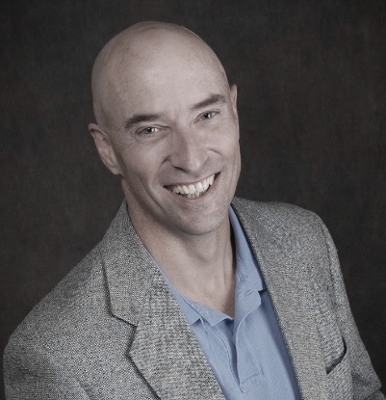
“Building Trustworthy Organizations –
One Leader, One Team at a Time”
Rob Benson
Lead Consultant, Learning Unlimited

Thursday – June 27
Doubletree Hotel – Downtown Tulsa

Our old friend is back – this time for the Tulsa Chapter on September 26:

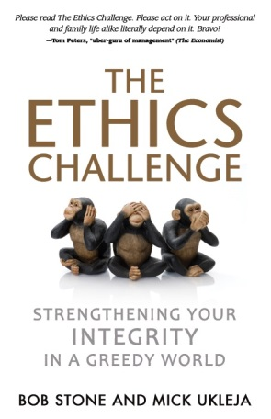
Mick Ukleja, co-author of The Ethics Challenge: Strengthening Your Integrity in a Greedy World will share insights that will help individuals move beyond compliance into a courageous leadership methods that transform organizations. His ideas have been praised by prominent leaders such as business guru Tom Peters who said, “Please read The Ethics Challenge. Please act on it. Your professional and family life alike literally depend on it.”

Ken Blanchard said of the book: “When you read The Ethics Challenge, you’ll see that ethics is alive and well in America. Bob and Mick have written an important book for today’s leaders.”

Mick is Chairman of the Board of Trustees for the Astronauts Memorial Foundation at the Kennedy Space Center which oversees the center for space education. He has been featured on Fox News, CNN, Fox Business Network, NBC, and numerous publications.
Recommended for 1 CPE in Ethics

Programs Focused on Integrity - (Not affiliated with OK Ethics)
Since the beginning, OK Ethics members have been inspired by our friendship with Character First. Leaders with this organization provided the wisdom and insight for OK Ethic's Guiding Principles. Go to www.characterfirst.com to learn more about tools to help you integrate character and ethics into your organizational culture, or contact John Burnett at 405-815-0001
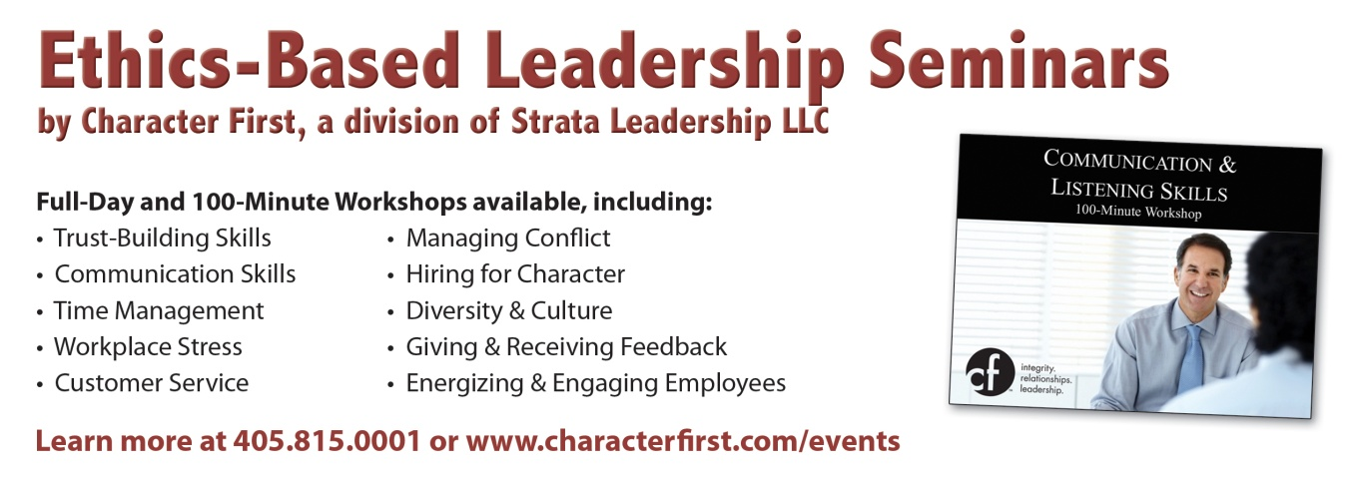
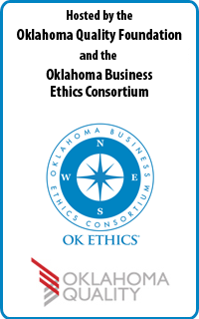
About Our Presenter:
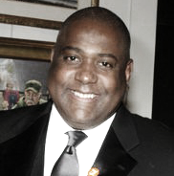
“THE REPUTATION DOCTOR
IS IN”

MIKE PAUL
President, MGP & Associates Public Relations; NYC
OK Ethics Compass Awards
Keynote Presentation
Petroleum Club, Oklahoma City
May 15, 2013

Our presenter has over 20 years’ experience in strategic PR, corporate communications, crisis PR, government relations and reputation management. He is known global as The Reputation Doctor, a nickname given to him over 15 years ago by a client. He is the president and senior counselor of MGP & Associates PR (MGP).

MGP was founded by Mr. Paul in 1994 and is a leading, boutique, public relations and reputation management firm based in New York with local, national and international clients. The awarding-winning, virtual PR firm provides senior counseling services to top corporate, government, non-profit, sports and entertainment clients in both good times and bad.

Mr. Paul is known for building excellent teams of senior PR counselors and exceeding clients’ expectations. A few of the clients Mr. Paul has counseled over the years include: Citicorp, Merrill Lynch, Goldman Sachs, Nuveen, United Airlines, Verizon, Time Warner, Pfizer, Baxter Healthcare, Manor Care, Motorola, Timberland, Dunkin Donuts, Duracell, The Jackie Robinson Foundation, Boxing legends Muhammad Ali and Joe Frazier, NY Giants heroes Phil McConkey and Rodney Hampton, NY Jets legend Mark Gastineau, The Queen of Soul-Aretha Franklin, talk-radio star and bestselling author Dr. Laura Schlessinger, Dr. Ronald Lieberman (America’s Back Dr.), the World-Famous Laugh Factory Comedy Club, New York University, State University of New York, New School University, The King's College, American Red Cross, International Red Cross, Young Life, City Covenant Coalition, Vigilante Advertising, BrightLine Partners, Stratus Environmental and Metro Grass. Many other clients are not listed due to strict client confidentiality.

Mr. Paul is also a weekly guest news commentator regarding public individuals, organizations and corporations with reputations in crisis. He is interviewed weekly by top national and international T.V., radio and print news organizations including CNN, BBC, MSNBC, CNBC, ABC, NBC, CBS, Fox News, TruTV, ESPN, Sports Illustrated, Associated Press, Reuters, U.P.I., N.Y. Times, Wall Street Journal, National Public Radio and many others. Mr. Paul has been published in many leading magazines and professional journals. He is also a former political columnist and reporter. He is currently editor of a popular blog offering reputation advice called The Reputation Doctor.

Mr. Paul took a leave of absence from MGP from 1998-1999 to serve in the administration of former NYC Mayor Rudy Giuliani as EVP of communications, marketing and advertising for NYC Economic Development Corp. helping to retain and attract many businesses in New York City.

Special Note for CPE’s: Recommended for 1 CPE in Ethics at the basic level. Program is suitable for anyone in a leadership capacity who desires to promote a culture of ethical behavior.
Because of the spontaneity of the program, participants seeking CPE credit are urged to take notes in case of an audit. It is up to the individual attendees to demonstrate applicability to their own area of practice. OK Ethics makes no guarantees. Please be sure to pick up your CPE certificate at the end of the program as OK Ethics does not have the volunteer manpower to send these after the event has concluded.
Program Overview:
How does reputation tie in with ethical behavior? Mike Paul, AKA "The Reputation Doctor" will provide practical insights as to how successful companies lead from the heart to ensure that they consistently perform at an optimal level. BusinessWeek magazine called him "The Master of Disaster" for his counsel of global corporations and corporate executives with reputations in crisis.
Answers to the follow important ethical questions:
* Do we really understand what excellent, ethical behavior is?
* How do we avoid the slippery slope at work and in life?
* Are we striving for excellence in moral decision making with accountability?
Takeaways include the six building blocks to build an excellent reputation:
1. Truth
2. Honesty
3. Humility
4. Transparency
5. Accountability
6. Consistency
Interested in Receiving OK Ethics Monthly Meeting Notices?

OKC:
Contact Jalisha Petties, Member Care Coordinator
at (405) 889-0498 or via email okethics@yahoo.com

Interested in joining OK Ethics?
Contact Lynda Mobley, Vice President of Membership; Lynda.Mobley@oneok.com

General Program Disclaimer:
Members of the Oklahoma Business Ethics Consortium frequently share information concerning various issues and developments that may have legal implications. The discussions, commentary, and handouts at Consortium meetings or presentations to other organizations are for general informational purposes only. They cover only some aspects of the subject topic, and do not constitute a complete legal analysis of the topic or how it might apply to any particular set of facts. Before taking any action based on information presented during a Consortium event, participants are encouraged to consult a qualified attorney. The observations and comments of presenters at Consortium meetings and networking are the views and opinions of the presenter and do not constitute the opinion or policies of the Consortium or any of its members.

Presenters are respectfully requested to avoid profanity, preaching, politics, put-downs and self-promotion during their lectures


PLEASE LIKE ETHICS ON FACEBOOK

OKLAHOMA BUSINESS ETHICS CONSORTIUM ~ www.okethics.org

